Aleksas Murauskas

260718389

ECSE 429 Assignment 2

Question 1:

1. Generate a CFG

Some nodes have been condensed

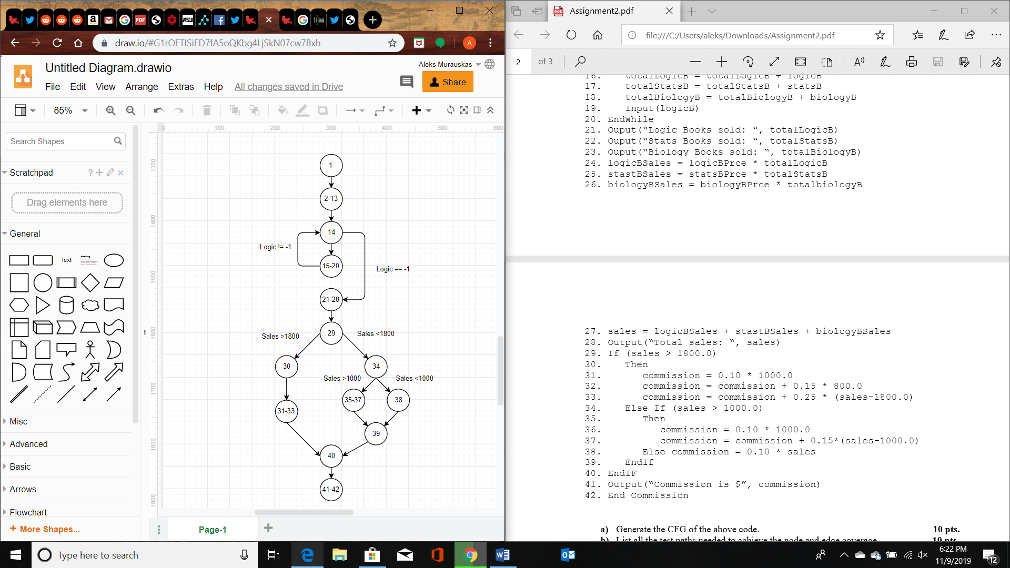

1. List all test paths needed to achieve node and edge coverage

$$Test 1:\left\{1,2-13,14,15-20,14,21-28,29,30,31-33,40,41-42\right\}$$

$$Test 2:\{1,2-13,14,21-28,29,34,35-37,39,40,41-42\}$$

$$Test 3:\{1,2-13,14,21-28,29,34, 38,39,40,41-42\}$$

C) Create a table listing where all variables, nodes/edges, where each variable is

|  |  |  |
| --- | --- | --- |
| Variable Name | Defined | Used |
| LogicB | 2-13 [line 2 and 13], 15-20 [line 19] | 14 [used as loop variable], 15-20 [line 16] |
| statsB | 2-13 [line 2], 15-20[line 15] | 15-20 [line 17] |
| biologyB | 2-13 [line 2], 15-20[line 15] | 15-20 [line 18] |
| logicBPrice | 2-13 [line 3 and 7] | 21-28 [line 24] |
| statsBPrice | 2-13 [line 3 and 8] | 21-28 [line 25] |
| totalBiologyB | 2-13 [line 4 and 12], 15-20 [line 18] | 15-20 [line 18], 21-28[line 23 and 26] |
| logicBSales | 2-13 [line 5], 21-28 [line 24] | 21-28 [line 27] |
| statsBSales | 2-13 [line 5], 21-28 [line 25] | 21-28 [line 27] |
| biologyBSales | 2-13 [line 5], 21-28 [line 26] | 21-28 [line 27] |
| Sales | 2-13 [line 6], 21-28 [line 27] | 21-28 [line 28], 29, Edge[29->30], Edge[29->34], 31-33 [line 33], 34, Edge[34->35-37], Edge[34->38], 35-37[line 37], 38 |
| Commission | 2-13[line 6], 31-33[line 31,32,33], 35-37[line 36 and 37], 38 | 31-33 [line 32 and 33], 35-37[line 37], 41-42 [line 41] |

Question 2:

A) Requirements

Node coverage: Select a test set T such that by executing P for each test case t in T, each node in P’s CFG is reached at least once

Edge coverage: Select a test set T such that by executing P for each test case t in T, each edge in P’s CFG is traversed at least once

Prime path coverage: A Prime path is a simple path that is not a subset of any other path. Prime path coverage covers all such prime paths.

B) Test paths that achieve node coverage but not edge coverage:

$$Test 1:\left\{n_{0},n_{3},n_{7}\right\}$$

$$Test 2:\left\{n_{1}, n_{4}, n_{8}\right\}$$

$$Test 3:\left\{n_{2}, n_{5},n_{9}\right\}$$

$$Test 4:\left\{n_{2}, n_{6},n_{9}\right\}$$

C) Test paths that achieve edge coverage but not prime path coverage:

$Test 1:\{n_{0},n_{3},n_{7}\}$

$Test 2:\{n_{0},n_{4},n_{7}\}$

$Test 3:\{n_{1},n_{4},n_{8}\}$

$Test 4:\{n_{1},n_{5},n_{8}\}$

$Test 5:\{n_{2},n_{5},n_{9}\}$

$Test 6:\{n_{2},n_{6},n_{9}\}$

Question 3:

A)

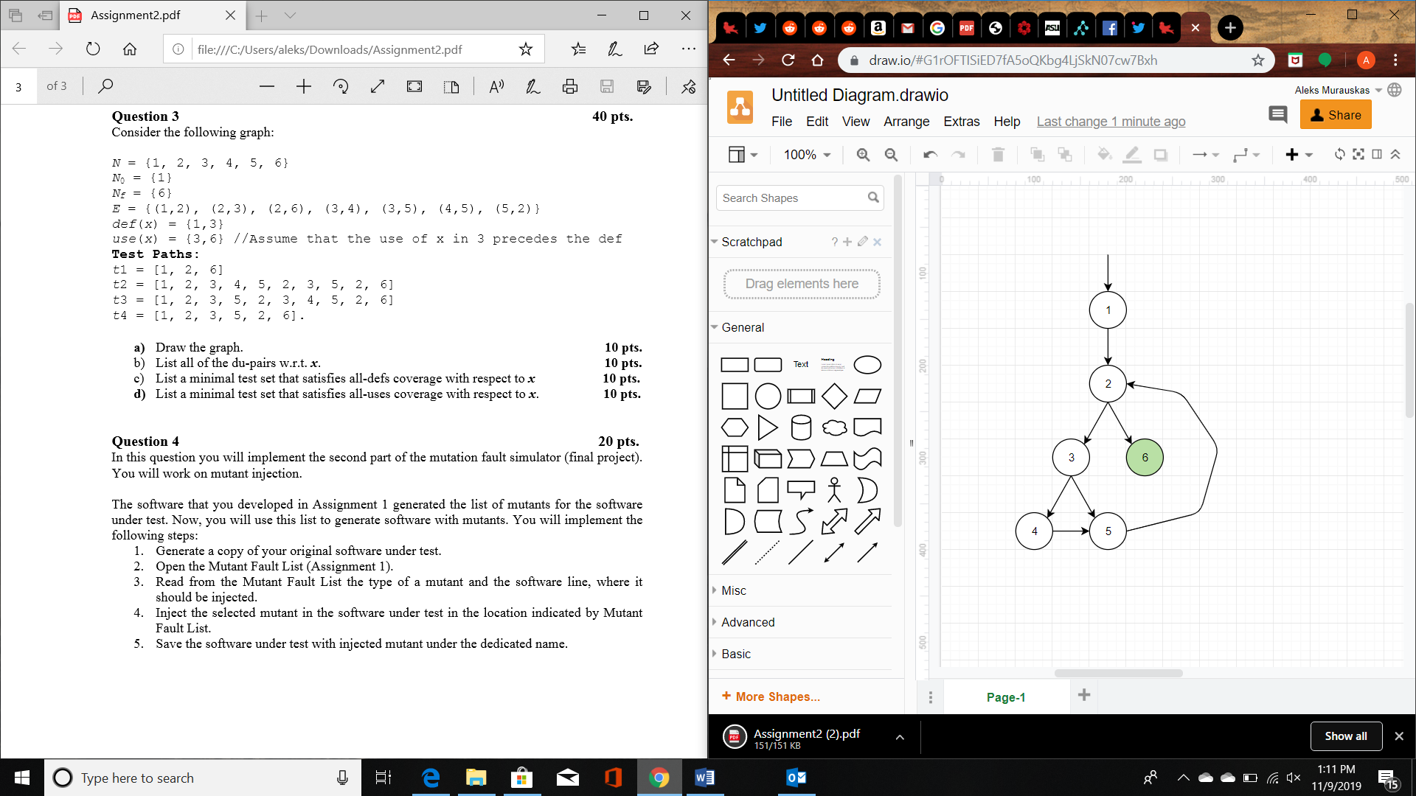

B) List all Du pairs

Def(x)={1,3}

Use(x) = {3,6}

A DU- pair is a pair of locations (l_i, l_j) s.t. that variable is defined at l_i and used at l_j.

Therefore DU-Pairs are {1,3}, {1,6}, {3,3}, {3,6}

C) List a minimal test set for all-defs

Node path: {1,2,3,5,2,6}

D) List a minimal test that satisfies all-uses

Node path: {1,2,3,5,2,6}

Question 4:

See attached file